Unsupervised machine learning is a type of machine learning in which a model learns patterns, structures, or relationships from unlabelled data. Unlike supervised learning, the dataset does not contain a target column that tells the model the correct answer.
For example, suppose an e-commerce company has customer data containing age, annual income, and spending score. It wants to discover customer groups without knowing those groups in advance. An unsupervised learning algorithm can identify these groups automatically.
1. Major unsupervised learning algorithms
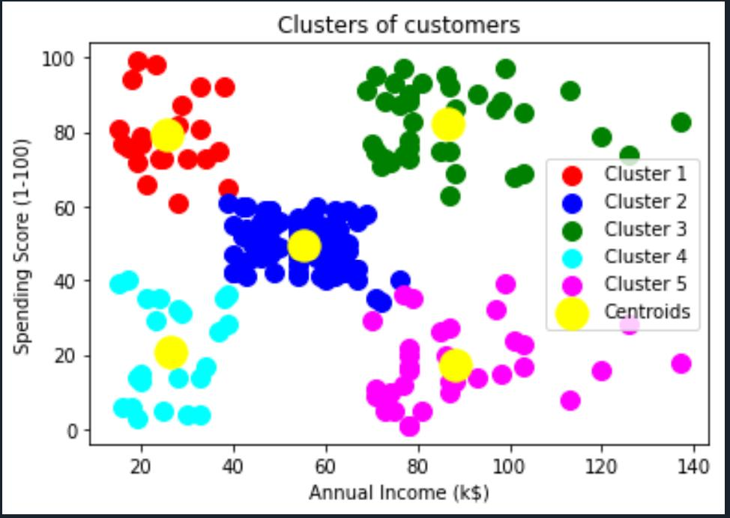
1. K-Means Clustering
Groups similar data points into \(K\) clusters by minimizing the sum of squared distances from each point to its cluster center.
Use cases: customer segmentation, grouping products.
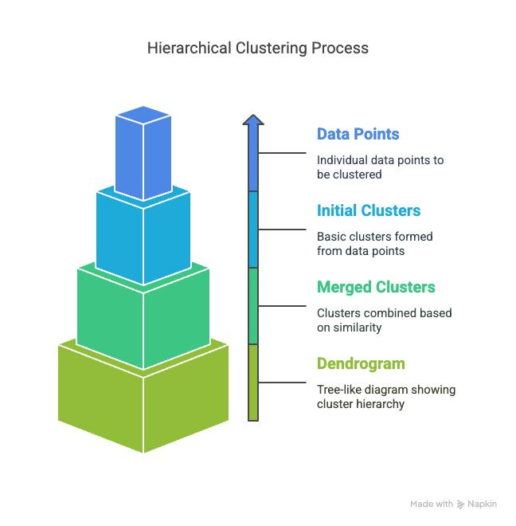
2. Hierarchical Clustering
Builds a hierarchy of clusters, often visualized using a dendrogram.
Use cases: biological taxonomy, grouping similar documents.
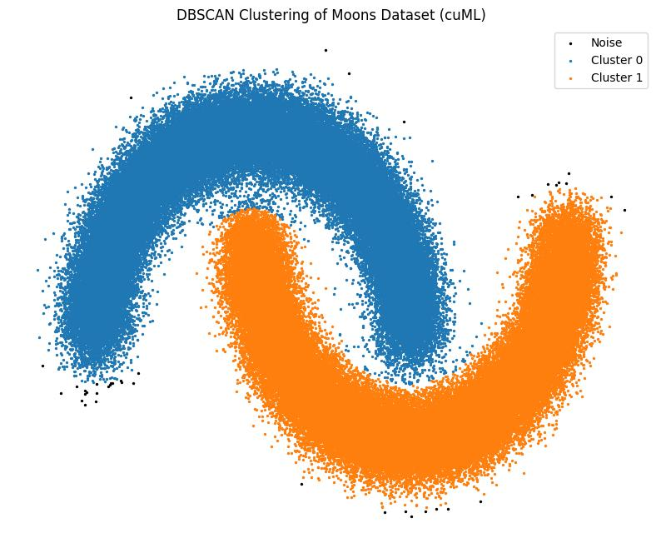
3. DBSCAN
Finds dense regions of data and labels isolated points as noise or outliers.
Use cases: anomaly detection, geographic data.
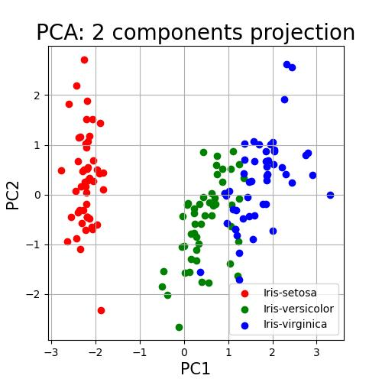
4. Principal Component Analysis (PCA)
Reduces the number of features while preserving as much data variance as possible.
Use cases: visualization, compression, preprocessing.
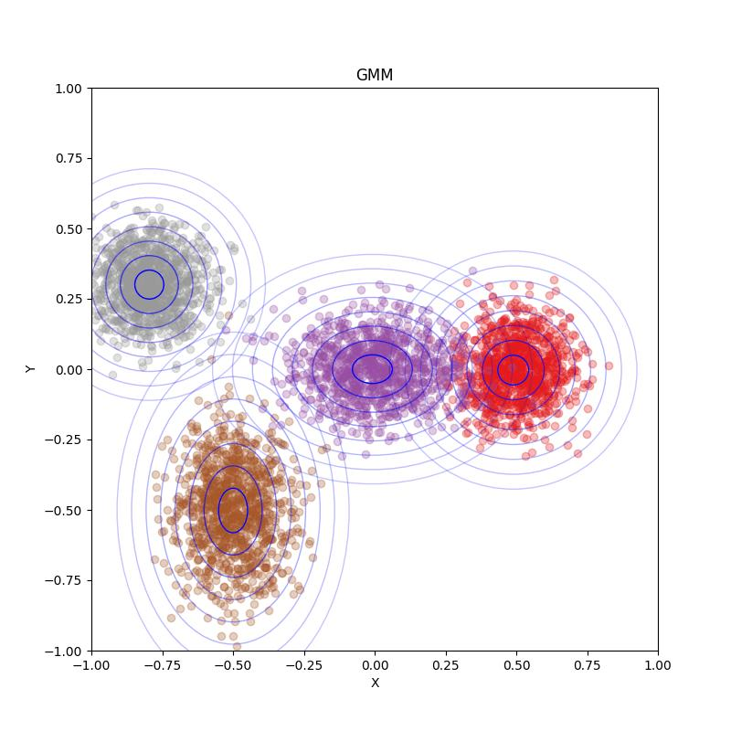
5. Gaussian Mixture Models (GMM)
Models data as a mixture of probability distributions and assigns each point probabilities of belonging to different clusters.
Use cases: overlapping customer groups, probabilistic clustering.
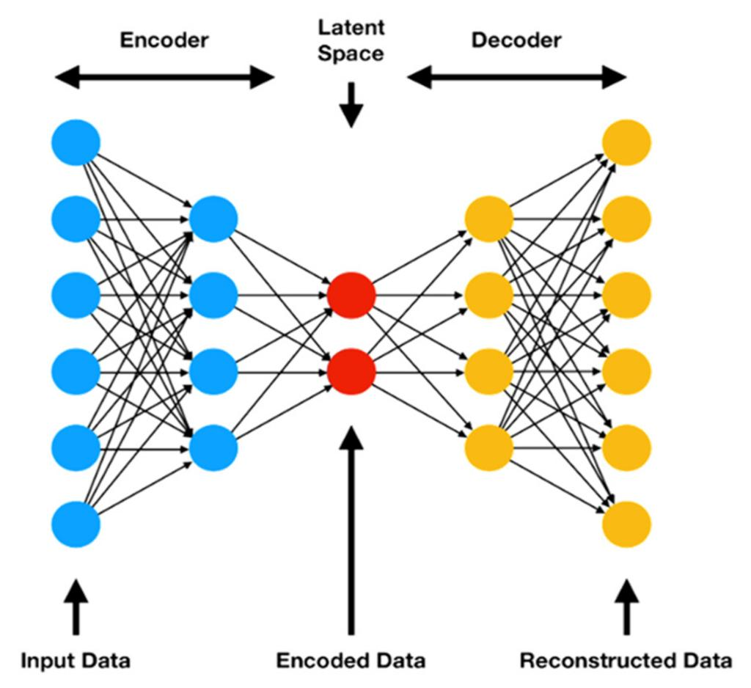
6. Autoencoders
Neural networks that learn compressed representations by reconstructing their input.
Use cases: feature learning, image compression, anomaly detection.
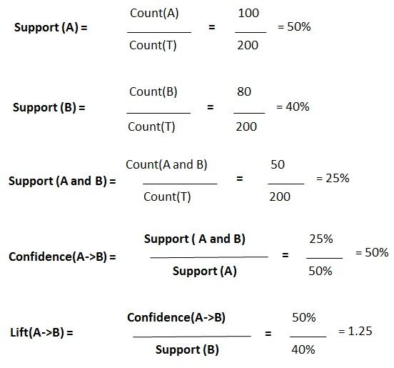
7. Association Rule Learning
Discovers relationships between items, such as products frequently purchased together.
Use cases: market basket analysis, product recommendations.
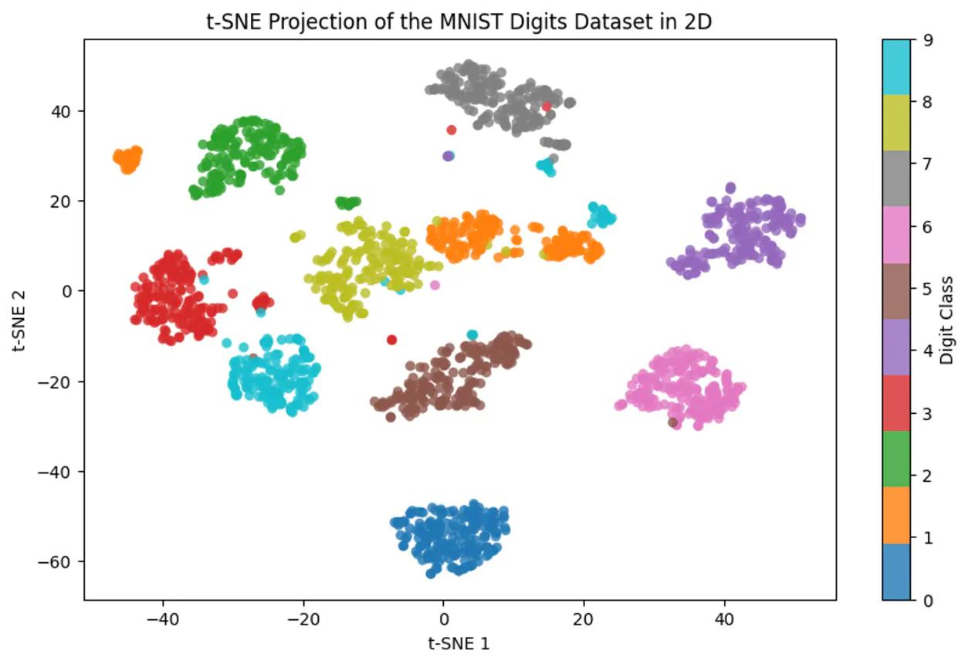
8. t-SNE and UMAP
Nonlinear dimensionality-reduction methods used primarily to visualize high-dimensional data.
Use cases: visualizing image embeddings, text embeddings, and complex datasets.
These algorithms solve different problems. Importantly, not every unsupervised algorithm uses a traditional loss function and an iterative optimizer. Some use geometric objectives, some maximize likelihood, and others use frequency-based rules or spectral decompositions.
2. What are a loss function and an optimizer?
Before learning the algorithms, understand these two important concepts.
Loss function
A loss function measures how well or poorly a model performs according to a defined objective.
For example, in K-Means, if data points are far from their assigned cluster centers, the clustering loss increases.
A general mathematical representation is:
\[ L(\theta)=\text{measure of error or objective} \]
Here, \(\theta\) represents the parameters being learned, such as cluster centers or neural network weights.
Optimizer
An optimizer is a method used to find better parameter values to minimize a loss or maximize an objective.
Common optimizers and optimization methods include:
- Gradient Descent: updates parameters using gradients of the loss.
- Adam: adapts the learning rate for individual parameters using moving averages of gradients.
- EM (Expectation-Maximization): alternates between estimating hidden assignments and updating model parameters.
- Lloyd's algorithm: repeatedly assigns points to the nearest centroid and recomputes the centroids.
- SVD / eigendecomposition: uses matrix decomposition to compute principal components.
An important distinction: not every algorithm uses a gradient-based optimizer. For example, DBSCAN does not train parameters by minimizing a differentiable loss.
3. K-Means clustering
K-Means divides data into \(K\) clusters. Each cluster is represented by a centroid, which is the mean of the points assigned to it.
Loss function: Within-Cluster Sum of Squares (WCSS)
\[ J=\sum_{i=1}^{N}\|x_i-\mu_{c_i}\|^2 \]
Where:
- \(N\) = number of data points.
- \(x_i\) = data point \(i\).
- \(\mu_{c_i}\) = centroid of the assigned cluster.
- \(c_i\) = cluster assignment.
The goal is to minimize the total squared distance between each point and its assigned centroid.

GitHub
+1
Optimizer: Lloyd's algorithm
- Initialize \(K\) centroids.
- Assign each point to its nearest centroid.
- Recalculate each centroid as the mean of its assigned points.
- Repeat until the assignments or centroids stop changing significantly.
Python example
Install the libraries if necessary:
pip install numpy pandas matplotlib scikit-learn
import matplotlib.pyplot as plt
from sklearn.cluster import KMeans
from sklearn.datasets import make_blobs
from sklearn.preprocessing import StandardScaler

# Generate unlabeled data
X, _ = make_blobs(
n_samples=300,
centers=3,
cluster_std=1.2,
random_state=42
)

# Scale features
X = StandardScaler().fit_transform(X)

# Train the model
model = KMeans(
n_clusters=3,
init="k-means++",
n_init=10,
random_state=42
)

labels = model.fit_predict(X)

print("Cluster labels:", labels[:10])
print("WCSS / inertia:", model.inertia_)

plt.scatter(X[:, 0], X[:, 1], c=labels)
plt.scatter(
model.cluster_centers_[:, 0],
model.cluster_centers_[:, 1],
marker="X",
s=200
)
plt.title("K-Means Clustering")
plt.show()
Interpretation: labels gives the cluster assigned to each point. model.inertia_ gives the WCSS for the fitted solution. Lower inertia indicates tighter clusters, but it generally decreases as you increase \(K\), so it cannot independently tell you the best number of clusters.
4. Hierarchical clustering
Hierarchical clustering builds a tree of nested clusters.
Two approaches are:
- Agglomerative: starts with individual points and repeatedly merges clusters.
- Divisive: starts with one cluster and repeatedly splits it.
Agglomerative clustering is the common approach in scikit-learn.
Loss function and optimization
There is no single universal loss function for hierarchical clustering. Its behavior depends on the linkage method.
For example, Ward linkage merges the clusters that produce the smallest increase in within-cluster sum of squares:
\[ \Delta J= \frac{n_A n_B}{n_A+n_B} \|\mu_A-\mu_B\|^2 \]
Here, \(A\) and \(B\) are two clusters, \(n_A,n_B\) are their sizes, and \(\mu_A,\mu_B\) are their means.
Other linkage methods use different criteria, such as minimum distance between points (single linkage) or maximum distance (complete linkage).
Optimizer: greedy bottom-up merging for agglomerative clustering. It does not use gradient descent.
Python example
import matplotlib.pyplot as plt
from sklearn.cluster import AgglomerativeClustering
from sklearn.datasets import make_blobs
from sklearn.preprocessing import StandardScaler

X, _ = make_blobs(
n_samples=200,
centers=3,
random_state=42
)

X = StandardScaler().fit_transform(X)

model = AgglomerativeClustering(
n_clusters=3,
linkage="ward"
)

labels = model.fit_predict(X)

plt.scatter(X[:, 0], X[:, 1], c=labels)
plt.title("Hierarchical Clustering")
plt.show()
Use case: discovering groups of similar customers, genes, or documents when the relationships between groups are also important.
5. DBSCAN clustering
DBSCAN stands for Density-Based Spatial Clustering of Applications with Noise.
Instead of representing clusters with centroids, DBSCAN identifies regions containing enough nearby data points.
Its two main parameters are:
- eps: maximum neighborhood distance.
- min_samples: minimum number of nearby samples required for a dense region, including the point itself in the usual implementation.
Loss function and optimizer
DBSCAN has no standard differentiable loss function to minimize. It follows density-based rules to identify core points, expand clusters, and mark noise.
Optimization method: neighborhood search and density-based cluster expansion, not gradient descent.
Python example
import matplotlib.pyplot as plt
from sklearn.cluster import DBSCAN
from sklearn.datasets import make_moons
from sklearn.preprocessing import StandardScaler

X, _ = make_moons(
n_samples=300,
noise=0.06,
random_state=42
)

X = StandardScaler().fit_transform(X)

model = DBSCAN(
eps=0.25,
min_samples=5
)

labels = model.fit_predict(X)

print("Labels:", set(labels))
print("Noise points:", sum(labels == -1))

plt.scatter(X[:, 0], X[:, 1], c=labels)
plt.title("DBSCAN Clustering")
plt.show()
Interpretation: a label of -1 represents noise. DBSCAN can discover non-spherical clusters that K-Means may struggle with, but results depend strongly on the distance scale and density parameters.

scikit-learn 1.9.1 documentation
+1
6. Gaussian Mixture Model (GMM)
A Gaussian Mixture Model assumes that the dataset was generated by a mixture of several Gaussian probability distributions.
Unlike K-Means, which assigns each point to one cluster, GMM can provide a probability of belonging to each cluster.
For example, a customer could have a 70% probability of belonging to cluster A and a 30% probability of belonging to cluster B.
Loss function: Negative Log-Likelihood
GMM typically maximizes the likelihood of the observed data. Equivalently, it minimizes the negative log-likelihood:
\[ J=-\sum_{i=1}^{N}\log \left[ \sum_{k=1}^{K} \pi_k\,\mathcal{N}(x_i\mid\mu_k,\Sigma_k) \right] \]
Where:
- \(\pi_k\) = probability weight of component \(k\).
- \(\mu_k\) = mean of component \(k\).
- \(\Sigma_k\) = covariance matrix.
- \(\mathcal{N}\) = Gaussian probability density function.
Optimizer: Expectation-Maximization (EM)
EM repeatedly performs two steps:
- E-step: estimates the probability that each data point belongs to each Gaussian component.
- M-step: updates the means, covariance matrices, and component weights using those probabilities.
Repeat until the likelihood converges or the iteration limit is reached.
Python example
import matplotlib.pyplot as plt
from sklearn.mixture import GaussianMixture
from sklearn.datasets import make_blobs
from sklearn.preprocessing import StandardScaler

X, _ = make_blobs(
n_samples=300,
centers=3,
cluster_std=1.5,
random_state=42
)

X = StandardScaler().fit_transform(X)

model = GaussianMixture(
n_components=3,
covariance_type="full",
random_state=42
)

model.fit(X)

labels = model.predict(X)
probabilities = model.predict_proba(X)

print("Negative log-likelihood:", -model.score(X))
print("First five probability assignments:")
print(probabilities[:5])

plt.scatter(X[:, 0], X[:, 1], c=labels)
plt.title("Gaussian Mixture Model")
plt.show()
Note: model.score(X) returns the average log-likelihood per sample, so its negative is the average negative log-likelihood. It is not the total negative log-likelihood.
GMM is useful when clusters overlap or have different shapes and covariance structures.
scikit-learn 1.9.1 documentation
+1
7. Principal Component Analysis (PCA)
PCA reduces the number of features while preserving as much variance as possible in the retained components.
Suppose a dataset has 100 features. PCA might transform it into 10 principal components, making visualization or downstream modeling easier.
Objective function
PCA is often described as maximizing the variance captured by the projected data:
$$\max_{W^{⊤}W=I}{\operatorname{Tr}\left(W^{⊤}SW\right)}$$Where:
S = covariance matrix of the centered data.
W = matrix containing the selected principal directions.
I = identity matrix.
Tr = matrix trace.
An equivalent formulation minimizes the squared reconstruction error after projection onto the selected subspace.
Optimizer: SVD or eigendecomposition
PCA commonly uses Singular Value Decomposition (SVD) or eigenvalue decomposition. These methods calculate principal directions directly; ordinary gradient descent is not required.
Scikit-learn's PCA centers the data but does not automatically standardize every feature. Scaling may be important when features use different units.
scikit-learn 1.9.1 documentation
+1
Python example
import matplotlib.pyplot as plt
from sklearn.datasets import load_iris
from sklearn.preprocessing import StandardScaler
from sklearn.decomposition import PCA

# Ignore the target labels
X = load_iris().data

X_scaled = StandardScaler().fit_transform(X)

pca = PCA(n_components=2)
X_reduced = pca.fit_transform(X_scaled)

print("Original shape:", X.shape)
print("Reduced shape:", X_reduced.shape)

print(
"Variance explained:",
pca.explained_variance_ratio_
)

print(
"Total variance retained:",
pca.explained_variance_ratio_.sum()
)

plt.scatter(X_reduced[:, 0], X_reduced[:, 1])
plt.xlabel("Principal Component 1")
plt.ylabel("Principal Component 2")
plt.title("PCA: Two-Dimensional Representation")
plt.show()
Interpretation: the first two principal components summarize the largest possible amount of variance among all two-dimensional linear projections. They do not necessarily preserve every meaningful cluster or relationship.
8. Autoencoders
An autoencoder is a neural network trained to reconstruct its input. It learns a compressed representation called a latent representation.
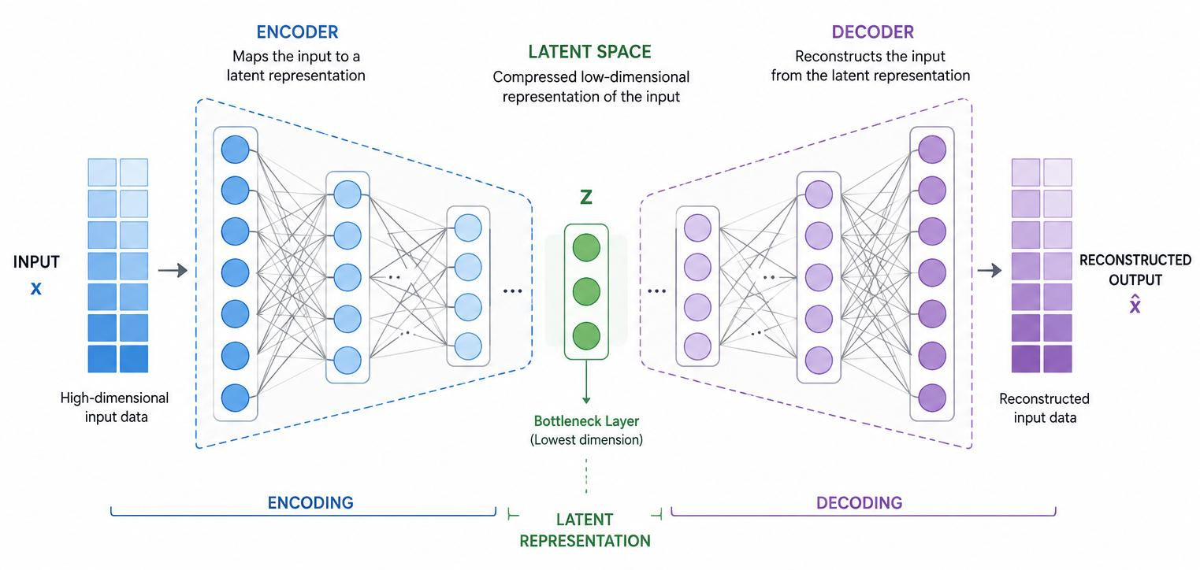
colabcodes.com
It consists of three conceptual parts:
- Encoder: converts input data into a smaller representation.
- Bottleneck: stores the compressed features.
- Decoder: reconstructs the original input from those features.
Loss function: Reconstruction loss
For continuous-valued data, a common choice is Mean Squared Error (MSE):
$$L=\frac{1}{N}\sum_{i=1}^{N}{{\left\|x_{i}-{\overset{ˆ}{x}}_{i}\right\|}^{2}}$$

Where x_i is the original input and \(\hat{x}_i\) is the reconstructed input.
The model learns to minimize the difference between the original data and the reconstruction. Other reconstruction losses are appropriate for other data types.
The model learns to minimize the difference between the original data and the reconstruction. Other reconstruction losses are appropriate for other data types.
Optimizer: Adam or SGD
Unlike K-Means or PCA, a neural network autoencoder is usually trained using backpropagation and a gradient-based optimizer such as Adam.
Python example using PyTorch
Install PyTorch if necessary, following the instructions for your operating system at the official PyTorch installation page.
import torch
from torch import nn
from torch.utils.data import DataLoader, TensorDataset
from sklearn.datasets import load_iris
from sklearn.preprocessing import StandardScaler

# Prepare unlabeled input data
X = load_iris().data
X = StandardScaler().fit_transform(X)

X_tensor = torch.tensor(X, dtype=torch.float32)
loader = DataLoader(
TensorDataset(X_tensor),
batch_size=16,
shuffle=True
)

class Autoencoder(nn.Module):
def __init__(self):
super().__init__()

self.encoder = nn.Sequential(
nn.Linear(4, 3),
nn.ReLU(),
nn.Linear(3, 2)
)

self.decoder = nn.Sequential(
nn.Linear(2, 3),
nn.ReLU(),
nn.Linear(3, 4)
)

def forward(self, x):
latent = self.encoder(x)
reconstructed = self.decoder(latent)
return reconstructed

model = Autoencoder()
loss_fn = nn.MSELoss()
optimizer = torch.optim.Adam(
model.parameters(),
lr=0.001
)

for epoch in range(100):
total_loss = 0

for (batch,) in loader:
optimizer.zero_grad()

reconstructed = model(batch)
loss = loss_fn(reconstructed, batch)

loss.backward()
optimizer.step()

total_loss += loss.item() * len(batch)

if (epoch + 1) % 20 == 0:
print(
f"Epoch {epoch + 1}, "
f"Loss: {total_loss / len(X_tensor):.4f}"
)

with torch.no_grad():
latent_features = model.encoder(X_tensor)
reconstructed = model(X_tensor)

print("Latent shape:", latent_features.shape)
print(
"Final reconstruction MSE:",
loss_fn(reconstructed, X_tensor).item()
)Interpretation: the original four features have been compressed into two learned features. The reconstruction loss measures how well the network reproduces the inputs.
Important: a low reconstruction loss does not automatically mean the learned features are useful. The architecture, data, and evaluation task matter.
9. Association Rule Learning
Association rule learning discovers items or events that frequently occur together.
For example:
$$\left\{\text{Bread}\right\}→\left\{\text{Butter}\right\}$$This means that transactions containing bread may also contain butter. It does not establish that bread purchases cause butter purchases.
Two popular algorithms are:
- Apriori: discovers frequent itemsets using the downward-closure property.
- FP-Growth: uses a compressed tree representation to mine frequent itemsets without explicitly generating every candidate itemset.
Is there a loss function or optimizer?
Traditional association rule mining generally has no differentiable loss function and no gradient-based optimizer. Instead, algorithms find frequent itemsets and evaluate rules using measures such as:
- Support: fraction of transactions containing both items.
- Confidence: fraction of transactions containing the antecedent that also contain the consequent.
- Lift: how much more frequently the items occur together than expected if they were independent.
These are evaluation measures, not training loss functions.

mlxtend
+1

Python example: Apriori
Install the required package:
pip install mlxtend pandas
import pandas as pd
from mlxtend.frequent_patterns import apriori
from mlxtend.frequent_patterns import association_rules

transactions = [
["Bread", "Butter", "Milk"],
["Bread", "Butter"],
["Bread", "Milk"],
["Butter", "Milk"],
["Bread", "Butter", "Milk"],
["Bread", "Butter"]
]

# Convert transactions to one-hot encoded data
items = sorted({
item
for transaction in transactions
for item in transaction
})

df = pd.DataFrame([
{
item: item in transaction
for item in items
}
for transaction in transactions
])

# Find frequent itemsets
frequent_itemsets = apriori(
df,
min_support=0.3,
use_colnames=True
)

print(frequent_itemsets)

# Generate association rules
rules = association_rules(
frequent_itemsets,
metric="confidence",
min_threshold=0.6
)

print(
rules[
["antecedents", "consequents",
"support", "confidence", "lift"]
]
)
Interpretation: a rule with confidence 0.8 means that 80% of transactions containing the antecedent also contain the consequent. Lift above 1 indicates a positive association relative to independence, although the strength and usefulness of the relationship need further assessment.
10. t-SNE and UMAP
These algorithms are primarily used to visualize high-dimensional data in two or three dimensions.
For example, word embeddings might contain 300 numerical features. t-SNE or UMAP can project them into two dimensions so you can inspect patterns visually.
t-SNE
Objective: t-SNE converts similarities between high-dimensional points and low-dimensional points into probability distributions, then minimizes their Kullback–Leibler (KL) divergence:
$$L=\sum_{i≠j}{p_{ij}}\log\left(\frac{p_{ij}}{q_{ij}}\right)$$Here, \(p_{ij}\) represents high-dimensional similarities and \(q_{ij}\) represents low-dimensional similarities.
Optimizer: gradient-based optimization, commonly using gradient descent variants.
UMAP
UMAP constructs a fuzzy neighborhood graph and optimizes a low-dimensional representation to preserve important neighborhood relationships.
Its optimization objective is based on cross-entropy between fuzzy relationships in the original and embedded spaces. The implementation uses stochastic optimization, including variants of stochastic gradient descent.
Python example
pip install umap-learn
import matplotlib.pyplot as plt
from sklearn.datasets import load_iris
from sklearn.preprocessing import StandardScaler
from sklearn.manifold import TSNE
import umap

X = load_iris().data
X = StandardScaler().fit_transform(X)

# t-SNE
tsne = TSNE(
n_components=2,
perplexity=30,
random_state=42,
init="pca",
learning_rate="auto"
)

X_tsne = tsne.fit_transform(X)

# UMAP
umap_model = umap.UMAP(
n_components=2,
n_neighbors=15,
min_dist=0.1,
random_state=42
)

X_umap = umap_model.fit_transform(X)

fig, axes = plt.subplots(1, 2, figsize=(12, 5))

axes[0].scatter(X_tsne[:, 0], X_tsne[:, 1])
axes[0].set_title("t-SNE")

axes[1].scatter(X_umap[:, 0], X_umap[:, 1])
axes[1].set_title("UMAP")

plt.show()
These plots deliberately ignore the Iris target labels. The algorithms learn embeddings from the features alone. Although t-SNE and UMAP can reveal visual patterns, distances between distant groups and apparent cluster separation should not automatically be interpreted as proof of meaningful clusters.
11. Summary: Loss functions and optimizers compared
Algorithm | Objective / loss function | Optimization method
K-Means | Minimize WCSS | Lloyd's algorithm
Hierarchical clustering | Linkage-dependent criterion; Ward minimizes increase in WCSS | Greedy merging
DBSCAN | No standard differentiable loss | Density-based expansion
Gaussian Mixture Model | Negative log-likelihood | Expectation-Maximization (EM)
PCA | Maximize projected variance or minimize reconstruction error | SVD / eigendecomposition
Autoencoder | Reconstruction loss, such as MSE | Backpropagation + Adam or SGD
Apriori | No traditional loss; frequent-itemset support thresholds | Candidate generation and pruning
FP-Growth | No traditional loss; frequent-itemset support thresholds | FP-tree pattern mining
t-SNE | KL divergence | Gradient-based optimization
UMAP | Fuzzy-set cross-entropy objective | Stochastic optimization
For the mathematical formulations and algorithm behavior, see the scikit-learn unsupervised learning guide, clustering documentation, PCA documentation, and association rule documentation.

Which Unsupervised Learning Algorithm Should You Use?
The best algorithm depends on your goal, data shape, dataset size, and whether you need clusters, compressed features, anomaly detection, or relationships between items. The comparison below follows the practical guidance in the official scikit-learn unsupervised learning guide.

Main comparison:
Algorithm | Use it when… | Real-world example | Main limitation
K-Means | You want a predefined number of reasonably compact clusters | Segment customers into 4 groups | Sensitive to outliers and scaling; works best for roughly spherical clusters
Hierarchical clustering | You want a hierarchy of groups or a dendrogram | Group similar products or biological samples | Can be expensive for large datasets
DBSCAN | Clusters have irregular shapes and you want to identify noise | Find geographic hotspots and unusual points | Struggles when clusters have very different densities
HDBSCAN | You want density-based clustering with varying densities | Group spatial observations with different concentrations | Parameter choices and high-dimensional data can still be challenging
Gaussian Mixture Model (GMM) | Clusters overlap and you want membership probabilities | Identify customers who resemble multiple segments | Assumes a mixture of distributions; sensitive to model specification
PCA | You want fewer features while preserving linear variance | Reduce 100 numerical features to 10 | Captures linear structure; components may be hard to interpret
Autoencoder | You want nonlinear feature compression or learned representations | Compress images or detect unusual reconstruction errors | Needs suitable architecture, training, and data
Apriori | You want frequent item combinations in a small or moderate transaction dataset | Discover common shopping baskets | Candidate generation can become expensive
FP-Growth | You want frequent item combinations efficiently on larger transaction datasets | Analyze millions of shopping baskets | Performance depends on the number of frequent patterns and data structure
t-SNE | You want to visualize local neighborhood structure in 2D or 3D | Explore image or text embeddings | Primarily a visualization tool; global distances can be misleading
UMAP | You want a low-dimensional visualization that often preserves local structure efficiently | Explore clusters in high-dimensional embeddings | Results depend on parameters; visual separation is not proof of true clusters

One final practical point: unsupervised learning does not mean that evaluation is unnecessary. You can evaluate clustering using silhouette score, Davies–Bouldin index, or domain-specific checks; dimensionality reduction using retained variance or downstream performance; and anomaly detection using labeled validation examples when available. These evaluation metrics are distinct from the training objective or loss function.

